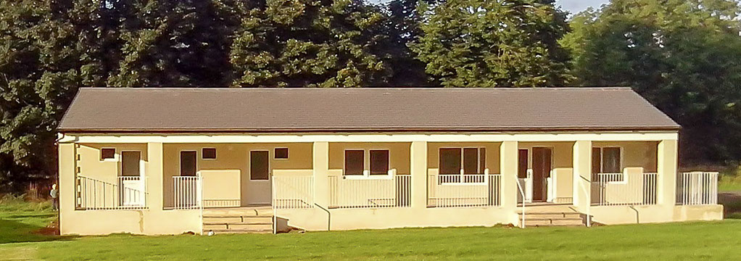

Burton in Lonsdale Recreation Field and Pavilion
Hire Charges 2023 until further notice

The excellent Recreation Field facilities are available for hire all year round. They are suitable for all ages - for sport and social activities, for children’s parties, family get-togethers, etc. And there’s parking for up to 20 cars.
Contact: telephone 07917 658045 or email bilparishcouncil@gmail.com
Charges:-
Playing Field £12 / hour Full day (6 hours or more) £72
Regular bookings: discounted rates available by negotiation

Pavilion
Social Room, incl kitchenette
Up to 5 hours £12 / hour Full day (6 hours or more) £72

Changing Rooms hire - please contact Burton in Lonsdale Parish Clerk

Multi Use Games Area (MUGA)

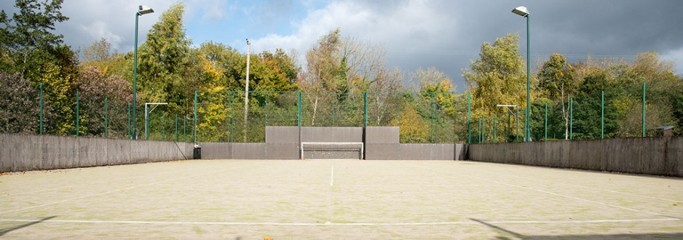

MUGA hire - please contact Burton in Lonsdale Parish Clerk

